Engagement Sample 1:
PAGE 1:
Duration of this page: 0 to 6 Seconds
TEXT: “Engagement Ceremony”
Duration of Text: 0 to 6.26 seconds
Font: lucien schoenschrift cat
Font Size: 77.5
Color: A8590C (Brown)
Position:
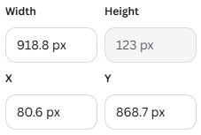
Animation:
Animation Type: Fade Animation, Writing Style : Element, Speed : 50% of Slide Bar inside Canva, and animation is both on entry and exit

TEXT: “INVITATION”
Duration of Text: 0 to 6.26 seconds
Font: Lora
Font Size: 49.1
Color: 3E3121 (Grey Brown)
Position:
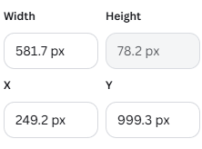
Animation:
Animation Type: Fade Animation, Writing Style : Element, Speed : 15% of Slide Bar inside Canva, and animation is both on entry and exit
Page 2:
Duration of this page: 6 to 12 Second
TEXT: “Partner 1 Name”
Duration of Text: 5.77 to 12.28 seconds
Font: Lucien Schoenschrift Cat
Font Size: 75.9
Color: 3C281D (Grey Brown)
Position:
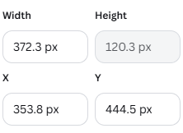
Animation:
Animation Type: Fade Animation, Writing Style : Element, Speed : 15% of Slide Bar inside Canva, and animation is both on entry and exit
TEXT: “Partner 2 Name”
Duration of Text: 6.26 seconds
Font: Lucien Schoenschrift Cat
Font Size: 74.6
Color: 3C281D (Grey Brown)
Position:
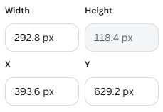
Animation:
Animation Type: Fade Animation, Writing Style : Element, Speed : 15% of Slide Bar inside Canva, and animation is both on entry and exit
Page 3:
Duration of this page: 12 to 18 Second
TEXT: “Partner 1 Name”
Duration of Text: 11.79 to 18.30 Second
Font: Lucien Schoenschrift Cat
Font Size: 90
Color: 3C281D (Grey Brown)
Position:
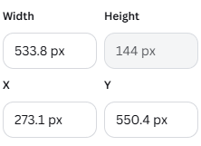
Animation:
Animation Type: Fade Animation, Writing Style : Element, Speed : 15% of Slide Bar inside Canva, and animation is both on entry and exit
TEXT: “Partner 2 Name”
Duration of Text: 11.79 to 18.30 Second
Font: Lucien Schoenschrift Cat
Font Size: 90
Color: 3C281D (Grey Brown)
Position:
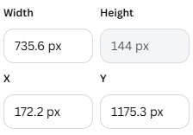
Animation:
Animation Type: Fade Animation, Writing Style : Element, Speed : 15% of Slide Bar inside Canva, and animation is both on entry and exit
TEXT: “Partner 1’s Parent’s Name”
Duration of Text: 11.79 to 18.30 Second
Font: Futura
Font Size: 20
Color: A8590C (Brown)
Position:
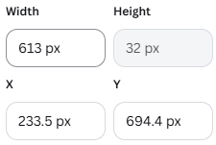
Animation:
Animation Type: Skate Animation, Direction of Animation Right to Left Writing Style : Element, Speed : 50% of Slide Bar inside Canva, and animation is both on entry and exit
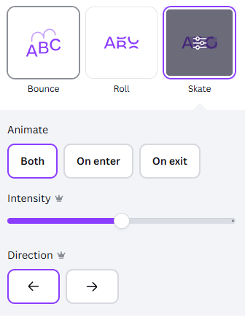
TEXT: “Partner 2’s Parent’s Name”
Duration of Text: 11.79 to 18.30 Second
Font: Futura
Font Size: 20
Color: A8590C (Brown)
Position:
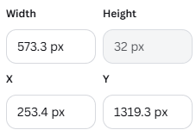
Animation:
Animation Type: Skate Animation, Direction of Animation Right to Left Writing Style : Element, Speed : 50% of Slide Bar inside Canva, and animation is both on entry and exit
Page 4:
Duration of this page: 18 to 24 Second
TEXT: “Month”
Duration of Text: 17.80 to 24 Second
Font: Lora
Font Size: 36.9
Color: A8590C (Brown)
Position:
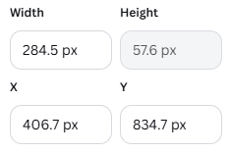
Animation:
Animation Type: Burst Animation, Writing Style : No Option to select in Canva for this animation, Speed : 50% of Slide Bar inside Canva, and animation is on entry only

TEXT: “Day”
Duration of Text: 17.80 to 24 Second
BOLDED TEXT
Font: Lora
Font Size: 36.9
Color: A8590C (Brown)
Position:
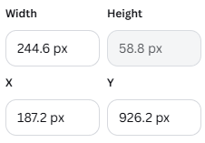
Animation:
Animation Type: Burst Animation, Writing Style : No Option to select in Canva for this animation, Speed : 50% of Slide Bar inside Canva, and animation is on entry only
TEXT: “Date”
Duration of Text: 17.80 to 24 Second
BOLDED TEXT
Font: Lora
Font Size: 74.7
Color: A8590C (Brown)
Position:
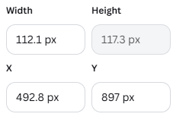
Animation:
Animation Type: Burst Animation, Writing Style : No Option to select in Canva for this animation, Speed : 50% of Slide Bar inside Canva, and animation is on entry only

TEXT: “Time”
Duration of Text: 17.80 to 24 Second
BOLDED TEXT
Font: Lora
Font Size: 37.8
Color: A8590C (Brown)
Position:
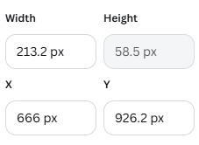
Animation:
Animation Type: Burst Animation, Writing Style : No Option to select in Canva for this animation, Speed : 50% of Slide Bar inside Canva, and animation is on entry only

TEXT: “Year”
Duration of Text: 17.80 to 24 Second
BOLDED TEXT
Font: Lora
Font Size: 24.9
Color: A8590C (Brown)
Position:
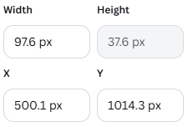
Animation:
Animation Type: Burst Animation, Writing Style : No Option to select in Canva for this animation, Speed : 50% of Slide Bar inside Canva, and animation is on entry only

TEXT: “Venue Details”
Duration of Text: 18.98 to 24 Second
BOLDED TEXT
Font: Lora
Font Size: 22.5
Color: 3C281E (Grey Brown)
Position:
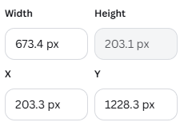
Animation:
Animation Type: Burst Animation, Writing Style : No Option to select in Canva for this animation, Speed: 50% of Slide Bar inside Canva, and animation is on entry only
